**Project Design Phase-II**

**Technology Stack (Architecture & Stack)**

|  |  |
| --- | --- |
| **Date** | **15 October 2022** |
| **Team ID** | **PNT2022TMID29343** |
| **Project Name** | **IoT based smart crop protection system for agriculture** |
| **Maximum Name** | **4 Marks** |

**Technical Architecture:**

**The Deliverable shall include the architectural diagram as below and the information as per the table1 & table2.**

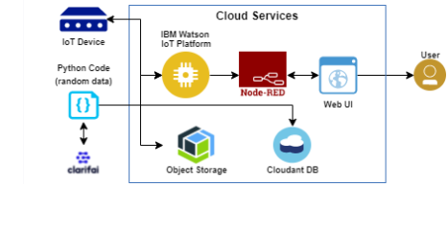

**Table-1: Components & Technologies:**

|  |  |  |  |
| --- | --- | --- | --- |
| **S.No** | Component | Description | Technology |
| **1.** | User Interface | How user interacts with the Web UI | App development |
| **2.** | Application Logic-1 | Logic for a process in the application | Python Objectives |
| **3.** | Application Logic-2 | Logic for a process in the application | IBM Watson STT service |
| **4.** | Application Logic-3 | Logic for a process in the application | Node-RED service |
| **5.** | Database | Data Type | Database Cloudant DB |
| **6.** | Cloud Database | Database Service on Cloud | Cloud Object store service |
| **7.** | File Storage | File storage requirements | IBM Block Storage |
| **.** | Infrastructure (Server / Cloud) | Application Deployment on Local System / Cloud Local Server Configuration:  Cloud Server Configuration: | Cloud Foundry |

|  |  |  |  |
| --- | --- | --- | --- |
| **S.No** | **Characteristics** | **Description** | **Technology** |
| **1.** | **Open-source Frameworks** | **The open-source frameworks used** | **SAN-SAF** |
| **2.** | **Security Implementations** | **List all the security / access controls implemented** | **IBM cloud encryptions** |
| **3.** | **Scalable Architecture** | **Justify the scalability of architecture (3 – tier,**  **Micro-services)** | **IBM cloud Architecture** |
| **4.** | **Availability** | **Justify the availability of applications (e.g. use of load balancers, distributed servers etc.)** | **Web Application can even be used by the framers in the horticulture** |
| **5.** | **Performance** | **Design consideration for the performance of the application** | **Since the web application is high efficient, it can be used by the farmers irrespective of time.** |